Monet vs Van Gogh
Color, Brushwork and the Experience of Place
  - Teacher lesson plan, comparison assignment, visual evidence cards, rubric and research record
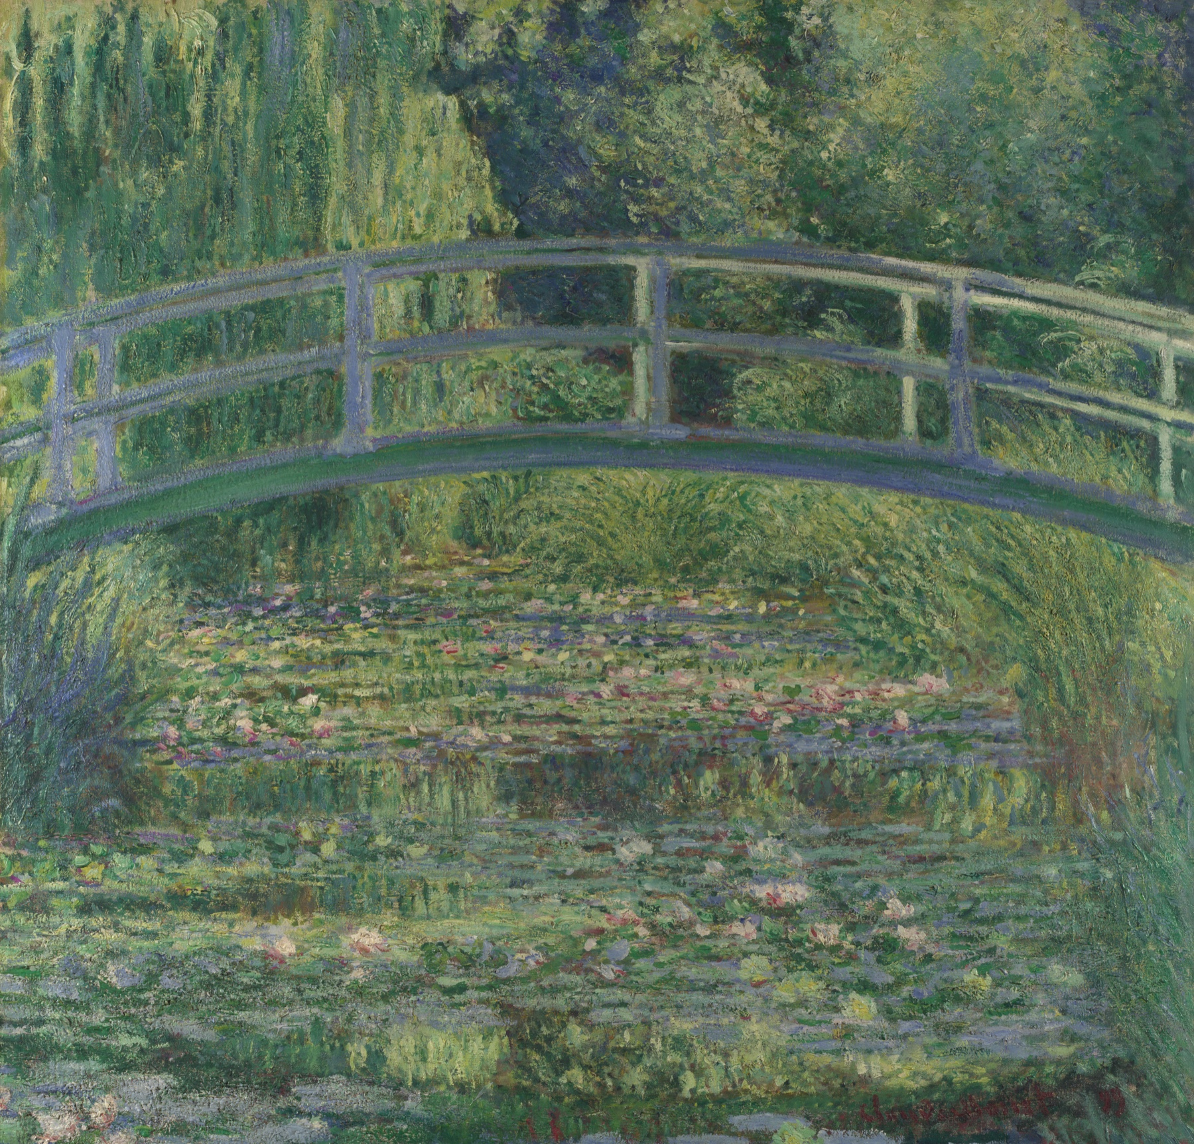  Claude Monet, The Water-Lily Pond, 1899 | 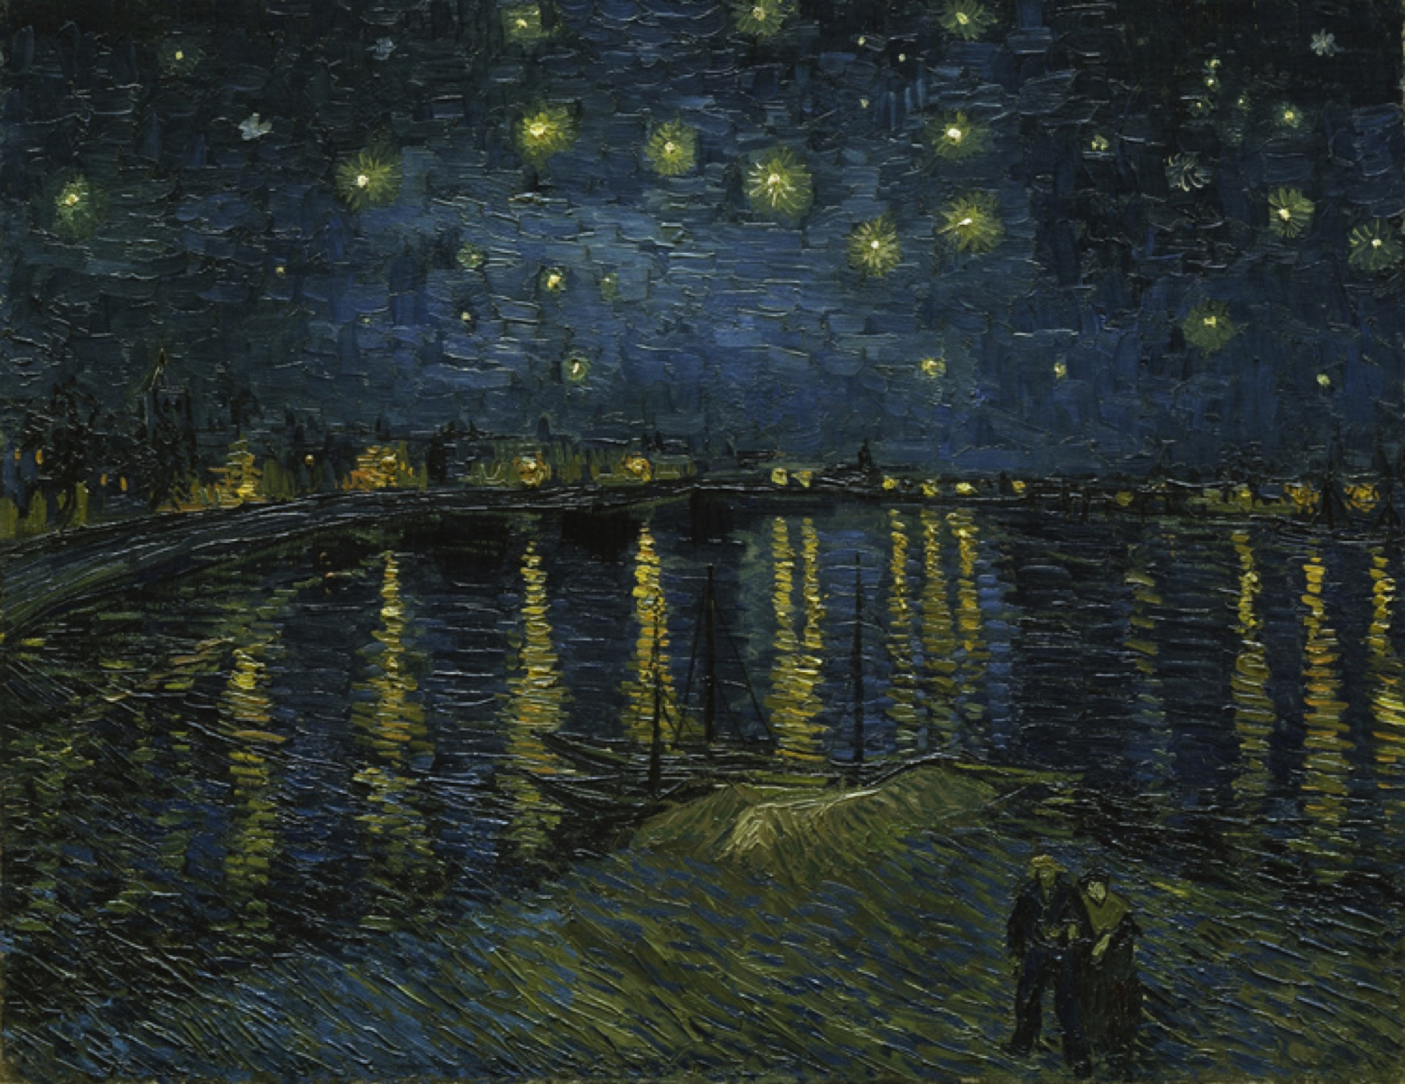  Vincent van Gogh, Starry Night Over the Rhône, 1888
CLASS LENGTH  60-90 min | LEVEL  Secondary / undergraduate | OUTPUT  Evidence-led comparison

Teacher lesson plan

Essential question
How do Monet and Van Gogh use repeated color and directional brushwork to make a familiar place feel unstable, immersive or emotionally charged?

Learning objectives
- Identify precise visual evidence and locate it within each image.
- Compare the same visual problem across two artworks instead of writing two separate summaries.
- Distinguish observable facts from supported interpretation.
- Write a comparative thesis that explains why a visual difference matters.

Materials
Projected classroom deck; printed evidence cards; student comparison assignment; access to the comparison tool and citation generator.
ASSESSMENT CHECKPOINTS  Listen for precise location words during discussion. Collect one relationship sentence before thesis writing. Use the rubric to identify one revision priority. | DIFFERENTIATION  Offer the supplied claim only after students describe each crop. Let developing writers use the thesis frame; ask advanced students to test an alternative argument. | EXTENSION / HOMEWORK  Choose one new Monet or Van Gogh work. Add one paired evidence relationship, verify the museum record and explain whether the original thesis still holds.

60-90 minute sequence
Time | Activity | Teacher action / student output
0-8 min | Silent looking | Show both paintings without titles. Students record three colors, three directional marks and one question.
8-18 min | Establish the objects | Reveal artist, date, movement, medium, dimensions and museum. Separate object facts from interpretation.
18-38 min | Paired evidence | Use the three evidence cards. For each pair, ask what is visible, where it appears and what relationship can be defended.
38-55 min | Small-group claim | Groups select one evidence pair and draft a relationship sentence using because, while or whereas.
55-72 min | Comparative thesis | Students combine at least two evidence pairs into one thesis that explains significance.
72-90 min | Review and export | Peer-score the thesis with the rubric, revise it and export the research record or citation.

Student comparison assignment
Name: ____________________________________ Date: __________________ Class: __________________

Task
Answer the essential question with evidence from both paintings. Do not write one paragraph about Monet and a separate paragraph about Van Gogh. Organize the response around shared visual problems.

1. Object facts
Confirm title, artist, date, movement, medium, dimensions and museum for both works.
________________________________________________________________________________
________________________________________________________________________________
________________________________________________________________________________

2. Paired evidence
Record at least two matched or contrasting details. State what is visible and where it appears.
________________________________________________________________________________
________________________________________________________________________________
________________________________________________________________________________

3. Relationship
Explain what the similarity or difference changes: attention, space, emotion, time or meaning.
________________________________________________________________________________
________________________________________________________________________________
________________________________________________________________________________

4. Thesis
Write one defensible sentence supported by evidence from both works.
________________________________________________________________________________
________________________________________________________________________________
________________________________________________________________________________
________________________________________________________________________________
________________________________________________________________________________

Visual evidence cards
Cut along the page breaks or display each pair. Ask students to describe the image before reading the supplied claim.

Evidence pair 1: Surface and depth
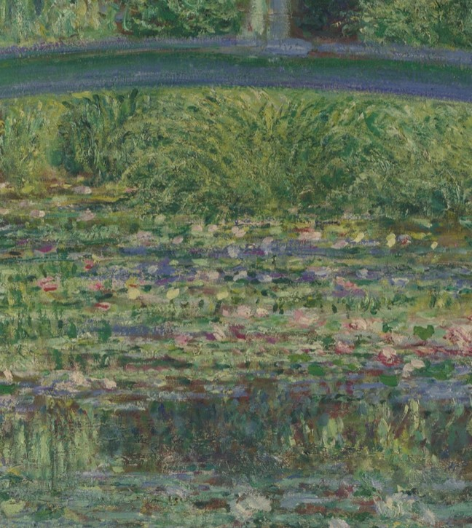  A / Monet  Reflected vegetation makes the pond oscillate between surface and depth. | 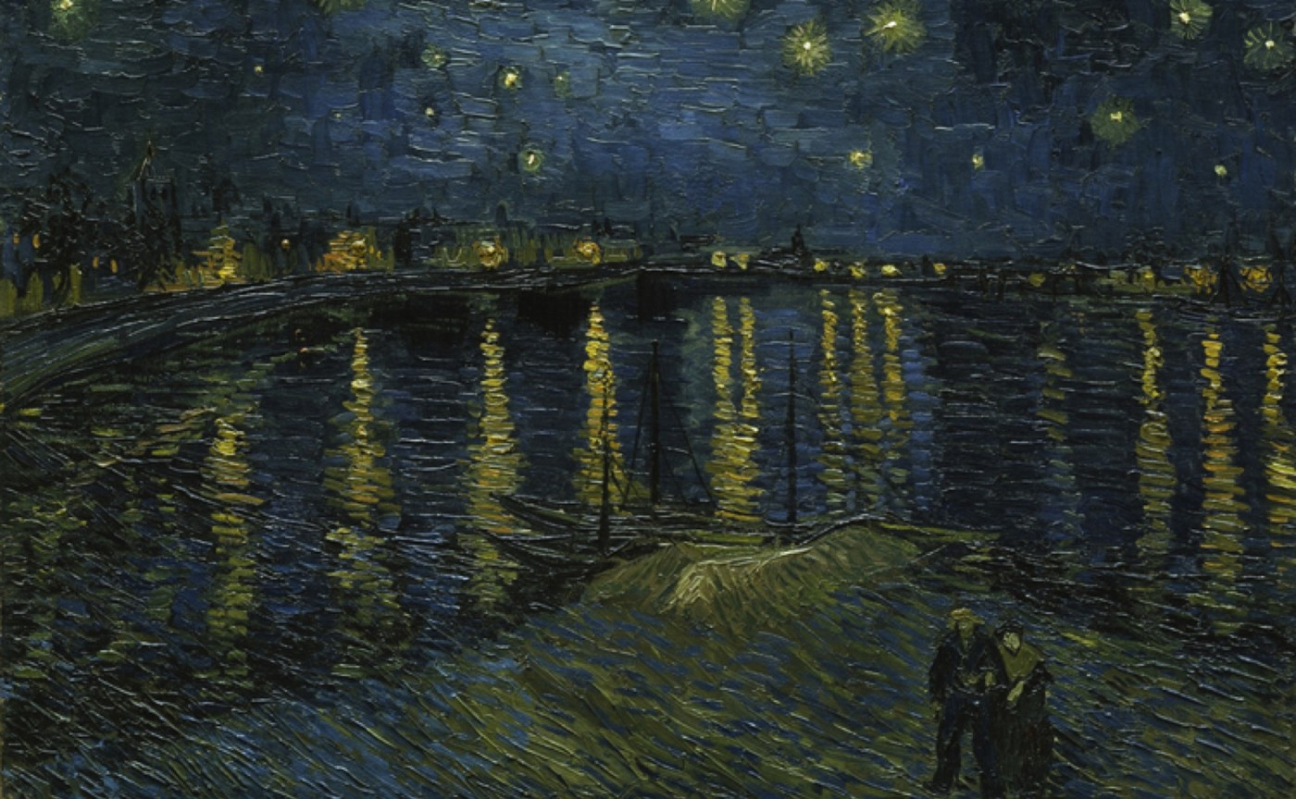  B / Van Gogh  Different blue stroke systems keep sky and river related but distinct.

Discussion
- What is directly visible in each crop?
- What relationship can be defended without guessing intention?
- What changes when this detail is returned to the complete painting?

Evidence pair 2: Color structure
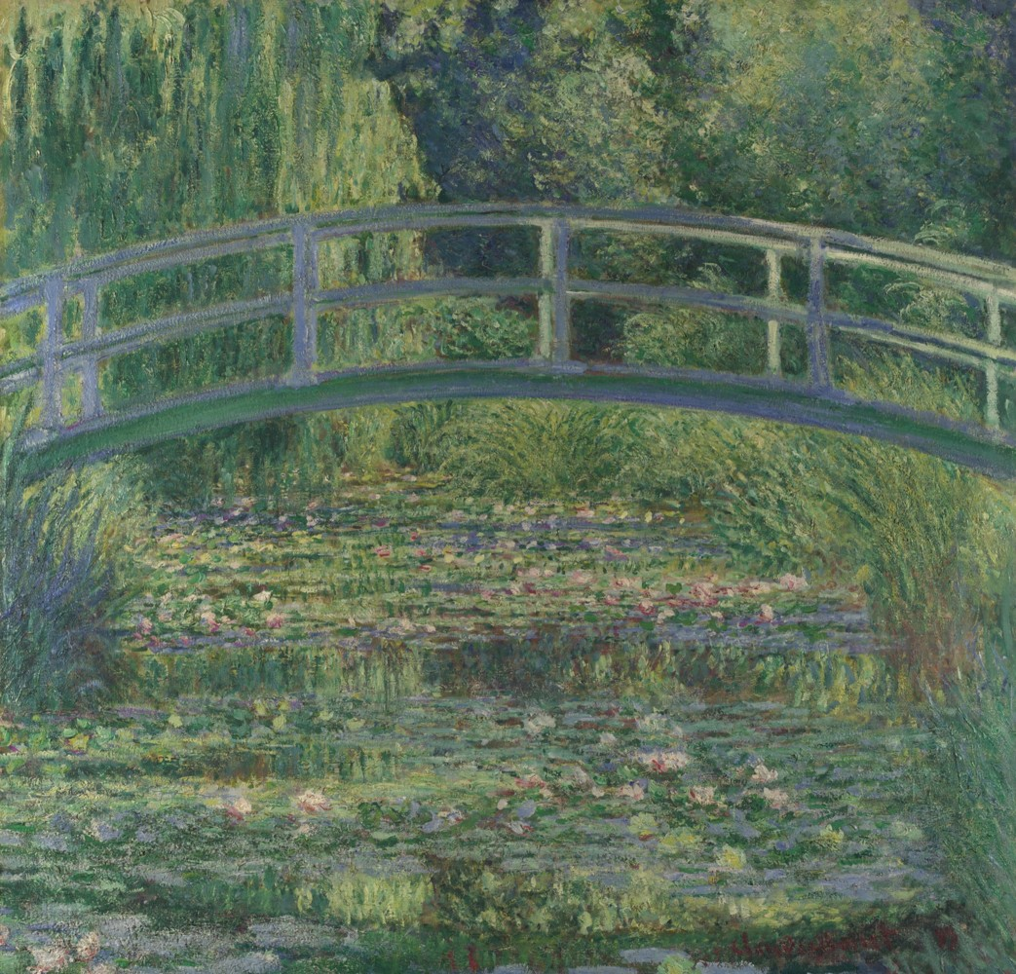  A / Monet  Green differentiates foliage, shadow, water and reflected growth. | 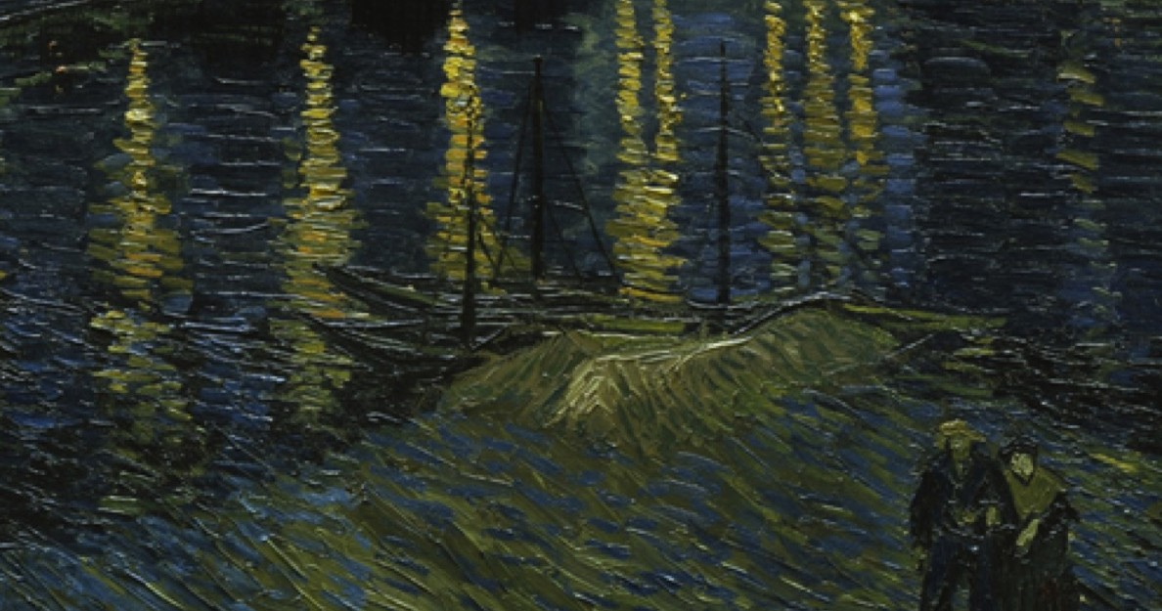  B / Van Gogh  Gold reflections turn distant lamps into paths toward the viewer.

Discussion
- What is directly visible in each crop?
- What relationship can be defended without guessing intention?
- What changes when this detail is returned to the complete painting?

Evidence pair 3: Human access
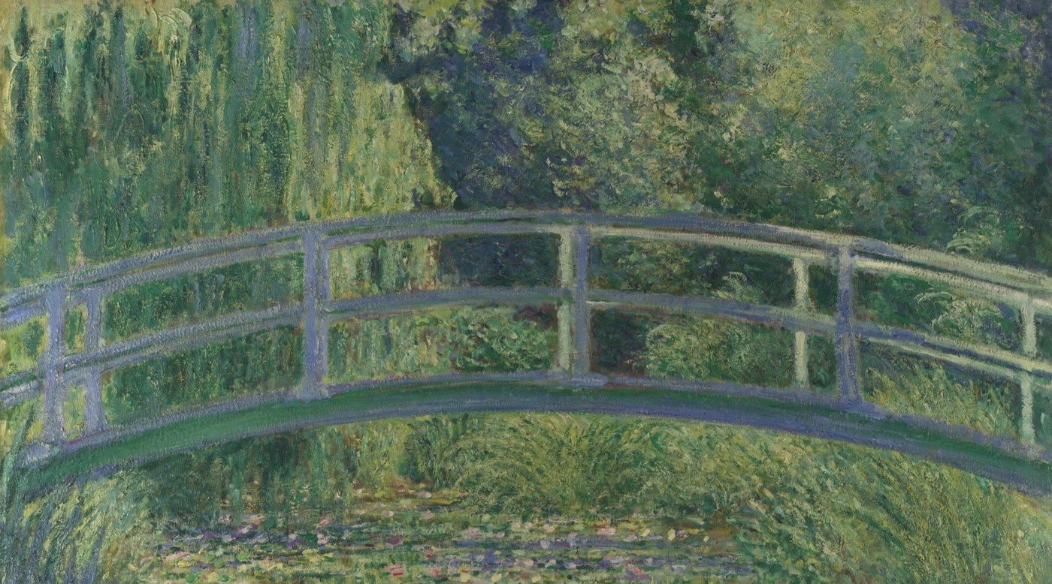  A / Monet  Dense vegetation closes the horizon and surrounds the viewer. | 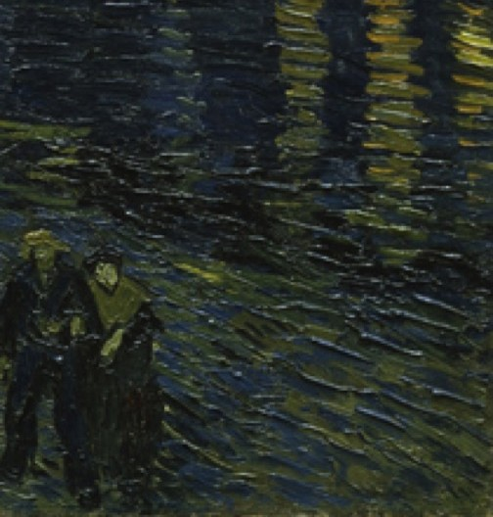  B / Van Gogh  A small foreground couple gives the river and sky a human scale.

Discussion
- What is directly visible in each crop?
- What relationship can be defended without guessing intention?
- What changes when this detail is returned to the complete painting?

Comparative analysis rubric
Criterion | Exceeds | Meets | Developing | Pts
Object accuracy | Titles, artists and dates are accurate; facts are separated from interpretation. | Minor errors or incomplete facts. | Major errors or facts treated as interpretation. | 20
Paired visual evidence | Uses precise evidence from both works and locates it clearly. | Uses both works but evidence is general or uneven. | Summarizes works separately or relies on unsupported description. | 30
Comparative reasoning | Explains what the relationship changes and why it matters. | Identifies similarity/difference with limited significance. | Lists similarities without analysis. | 25
Thesis and organization | A focused, editable thesis controls the response. | A thesis is present but broad or only partly supported. | No comparative thesis or two disconnected mini-essays. | 20
Sources and citation | Museum records and image/source information are retained. | Sources are incomplete or inconsistently formatted. | No traceable sources. | 5
Score: ______ / 100 Feedback priority: ________________________________________________

Research record and citation export

Claim log

Observed fact
________________________________________________________________________________
________________________________________________________________________________

Supported interpretation
________________________________________________________________________________
________________________________________________________________________________

Debated or unresolved question
________________________________________________________________________________
________________________________________________________________________________

Final comparative thesis
________________________________________________________________________________
________________________________________________________________________________

Source trail
- The National Gallery, London. The Water-Lily Pond by Claude Monet. https://www.nationalgallery.org.uk/paintings/claude-monet-the-water-lily-pond
- Musée d'Orsay. La Nuit étoilée by Vincent van Gogh. https://www.musee-orsay.fr/en/artworks/la-nuit-etoilee-78696
- Atlas of Paintings. Monet vs Van Gogh: Color, Brushwork and the Experience of Place. /research/comparisons/monet-vs-van-gogh-color-brushwork
Use the website citation generator to export MLA, Chicago or APA records for either artwork. Retain the holding institution record whenever facts or imagery are reused.

